|  |
| --- |
| Department of Software Engineering  Mehran University of Engineering and Technology, Jamshoro |

|  |  |  |  |
| --- | --- | --- | --- |
| Course: SW321–Computer networks and management | | | |
| Instructor | Aisha Ashraf | **Practical/Lab No.** | 04 |
| Date |  | **CLOs** | CLO-3: P5& CLO-4: P3 |
| Signature |  | **Assessment Score** | 1 Mark |

|  |  |
| --- | --- |
| Topic | To become familiar with the basic configuration of a switch using packet tracer software |
| Objectives | * To be able to configure switch using commands |

|  |
| --- |
| Lab Discussion: Theoretical concepts and Procedural steps |

**NETWORK SWITCH:**

A network **switch**is a small hardware device that joins multiple computers together within one local area network (LAN). Technically, network switches operate at layer two (Data Link Layer) of the OSI model.

Network switches appear nearly identical to [network hubs](http://compnetworking.about.com/cs/internetworking/g/bldef_hub.htm), but a switch generally contains more "intelligence" (and a slightly higher price tag) than a hub. Unlike hubs, network switches are capable of inspecting data [packets](http://compnetworking.about.com/library/glossary/bldef-packet.htm) as they are received, determining the source and destination device of that packet, and forwarding it appropriately. By delivering each message only to the connected device it was intended for, a network switch conserves [network bandwidth](http://compnetworking.about.com/library/glossary/bldef-bandwidth.htm) and offers generally better performance than a hub.

As with hubs, [Ethernet](http://compnetworking.about.com/cs/ethernet1/g/bldef_ethernet.htm) implementations of network switches are the most common. Mainstream Ethernet network switches support 10 [Mbps](http://compnetworking.about.com/library/glossary/bldef-kbps.htm), 100 Mbps, or 10/100 Mbps Ethernet standards.

Different models of network switches support differing numbers of connected devices. Most consumer-grade network switches provide either four or eight connections for Ethernet devices. Other switches are catalyst Cisco switches which can be configured accordingly as discussed in this lab activity.

**Lab equipment requirements**

To perform this lab you need 1 Cisco Catalyst 2950 Switch and at least 1 PC. However, most of the commands will work on other switch models as well. We are going to use two different PCs but they can be one and the same physical PC. You will need to connect them as depicted in the following the network diagram:

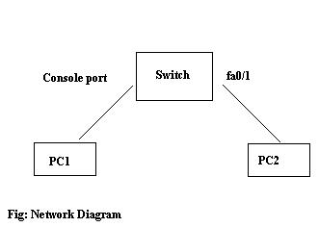

Connect the console cable to the to the console port on the switch and the other end to the serial port of PC1. Connect PC2 to first Fast Ethernet port (i.e. FA0/1) using an UTP/STP cable. PC1 must have a terminal client (i.e. Windows HyperTerminal) installed, and PC2 must be able to setup a telnet connection.

**SOFTWARE TOOL**

* Packet tracer 5.2

**TASK:Configuring the Switch**

Before you start with the configuration of the switch, clear the switch configuration by using the erase startup-config command or the erase nvram: command in Privileged EXEC mode, and then use the reload command to reboot the switch. After the switch rebooted, the following message will be displayed:

% Please answer 'yes' or 'no'.  
Would you like to enter the initial configuration dialog? [yes/no]

Type no and press ENTER.

Press ENTER when the message Press RETURN to get started appears.

Type enable at the Switch> command prompt.

Switch>enable

1. What changed in the switch prompt display and what does it mean?

After make it enable it goes in # command line writing mode.

**STEP 1: Change the switch's host name to SWswitch**

Enter configuration mode using the following command:  
Switch#configure terminal

a. Enter configure terminal at the privilege mode prompt.

switch#configure terminal

1. What prompt did the switch display?

Its comes in switch#(config) mode.

1. What does this prompt mean?

This means that now you can perform the commands on it. Changing time and its name etc.

Change the host name of the switch to "SWswitch" using the following command:  
Switch(config)#hostname SWswitch

a. What prompt did the switch display?

Switch0 name replaced by SWswitch.

1. What does this prompt mean?

This means that name has been changed our switch0 is now SWswitch.

1. What change has occurred in the prompt?

_______________________________________________________________________

**STEP 2: Configure passwords**

First set the enable secret to cisco123 using the following command:  
SWswitch(config)#enable secret cisco123

Next, set the password for all telnet lines to 'cisco456' using the following commands:

SWswitch (config)#line vty 0 15  
SWswitch (config-line)#password cisco456  
SWswitch (config-line)#login

Although the enable secret is encrypted, other passwords stored in the switch's configuration are still in clear text. You can see this by returning to Privileged EXEC mode and running the show running config:

SWswitch (config)#end (or press CTRL-Z)  
SWswitch#show running-config

Notice the enable secret is replaced by a hashed version, for example:  
enable secret 5 $1$iUjJ$cDZ03KKGh7mHfX2RSbDq

When you log on with the enable *secret*, the switch calculates the hash value again and compares it with the hash value stored in the configuration. If they match, you typed in the correct secret and will enter Privileged EXEC mode. You can configure a password by using the enable password command instead, but in contrary to the enable secret, the enable password is not encrypted by default. If an enable password *and* an enable secret are configured, you will need to enter the enable secret to logon. In other words, there’s no need to configure an enable password if you configured an enable secret.

Near the end of the configuration, you will notice the vty password you just configured, and that it is stored in plain text format. To ensure this password, as well as others such as the console password are also encrypted, use the service password-encryption command in Global configuration mode:

SWswitch#configure terminal   
SWswitch(config)#service password-encryption

If you would run the show running-config command in Privileged EXEC mode again, you will notice the vty password is now also encrypted. For example: 1511021F07257F717E

You can also set a password on the aux or console connection, for example to set the password to cisco789:

SWswitch (config)#line con 0  
SWswitch (config-line)#password cisco789  
SWswitch (config-line)#login

1. At Privileged EXEC mode type ‘show running-config’ and follow the details. __________________________________________________________________

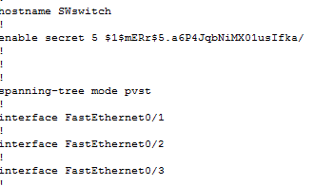

1. Is there an encrypted password?

Yes.

c. Are there any other passwords?

Yes.

1. Are any of the other passwords encrypted?

New password has been saved which is cisco789.

After that new password which was the secret cisco123 has been used to enable the swtich.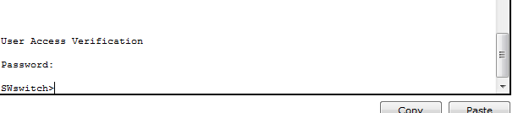

**STEP 3: Configure an IP address for the switch**

To be able to manage the switch using telnet, you will need to configure it with an IP address. Instead of assigning an IP address to one of the switch ports, we are going to assign an IP address to the *Management VLAN*.

Use the following commands to assign the IP address 192.168.0.9 to interface VLAN 1, which is the management VLAN by default:

SWswitch(config)#interface vlan 1  
SWswitch(config-if)#ip address 192.168.0.9 255.255.255.0

If you need to be able to connect to the switch from other networks, you will also need to configure a default gateway address. For example, if the switch is connected to a router with the IP address 192.168.0.254, use the following command, in Global Configuration mode, to use it as the default gateway:

SWswitch(config-if)#exit  
SWswitch(config)#ip default-gateway 192.168.0.254

**STEP 4: Establish a Telnet connection to the switch**

Configure PC2 (or PC1 if you are using only one PC) with an IP address from the same class C network as the switch, for example: 192.168.0.20 with subnet mask 255.255.255.0.

Open your favorite Telnet client and connect to the IP address you assigned to the switch. Instead of using a third-party client, you can just type the following on the command prompt:  
telnet 192.168.0.9

If you completed the steps above successfully, you should now be able to configure the switch through telnet in a similar manner as through the console terminal session. When the connection is established, you will first be prompted for the Telnet password. When you enter the correct password you will still have to use the enable command and enter the enable secret before you can change the configuration of the switch. Also note an enable secret (or enable password) must be configured or else the switch will not allow you to log on to Privileged Exec mode through telnet.

**STEP 5: Saving the configuration**

Saving the configuration on a modern Cisco Catalyst switch running IOS software works the same as on Cisco routers. This means you have to copy the running configuration (in RAM) to the startup configuration (in NVRAM) by using the following command in Privileged EXEC mode:

SWswitch#copy running-config startup-config

If you run the show startup-config command, you should get the same output as the show running-config command. The dirnvram: command should show the startup-config file with a size greater than zero. The configuration is also stored in the config.text file in flash, which content you can see by using the show flash command.

**STEP 6: Display switch hardware and firmware information**

The show version command allows you to display information about the switch’s hardware and IOS. The first half shows information about the IOS in flash, the boot loader on ROM, the uptime, what caused the switched to reboot, and the IOS edition it runs. The second half shows information about the hardware, including the interfaces, the memory and serial numbers.

SWswitch1#show version

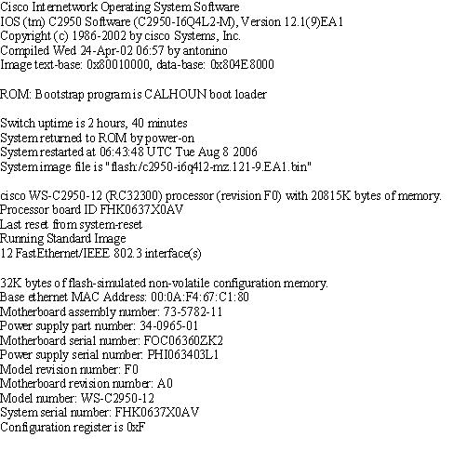

|  |
| --- |
| Lab Tasks |
| Submission Date: |

1. Execute the **show version** command on CISCO Packet Tracer to answer the following questions:

* What is the IOS version?
* Where was the router IOS image booted from?
* What type of processor (CPU) and how much RAM does this router have?
* How many Ethernet interfaces does this switch have?